Eclipse support c++11

I found [this](http://www.eclipse.org/forums/index.php/mv/msg/282618/787571/) article in the Eclipse forum, just followed those steps and it works for me. I am using Eclipse Indigo 20110615-0604 on Windows with a Cygwin setup.

* Make a new C++ project
* Default options for everything
* Once created, right-click the project and go to "Properties"
* C/C++ Build -> Settings -> Tool Settings -> GCC C++ Compiler -> Miscellaneous -> Other Flags. Put -std=c++0x (or for newer compiler version -std=c++11 at the end . ... instead of GCC C++ Compiler I have also Cygwin compiler
* C/C++ General -> Paths and Symbols -> Symbols -> GNU C++. Click "Add..." and paste __GXX_EXPERIMENTAL_CXX0X__ (ensure to append and prepend two underscores) into "Name" and leave "Value" blank.
* Hit Apply, do whatever it asks you to do, then hit OK.

If there is no Toolsettings in C/C++ build→settings, just go to Project Properties -> C/C++ Build -> Builder Settings -> (x) Generate Makefiles automatically then the tool settings tab under Settings will appear

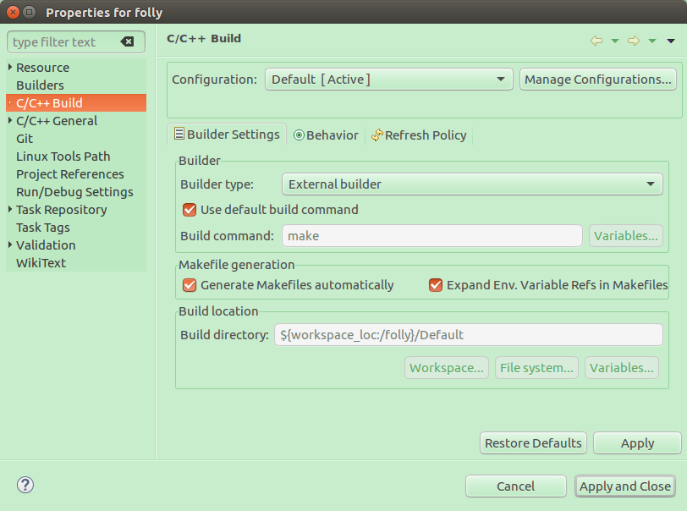

2021.01.01新增

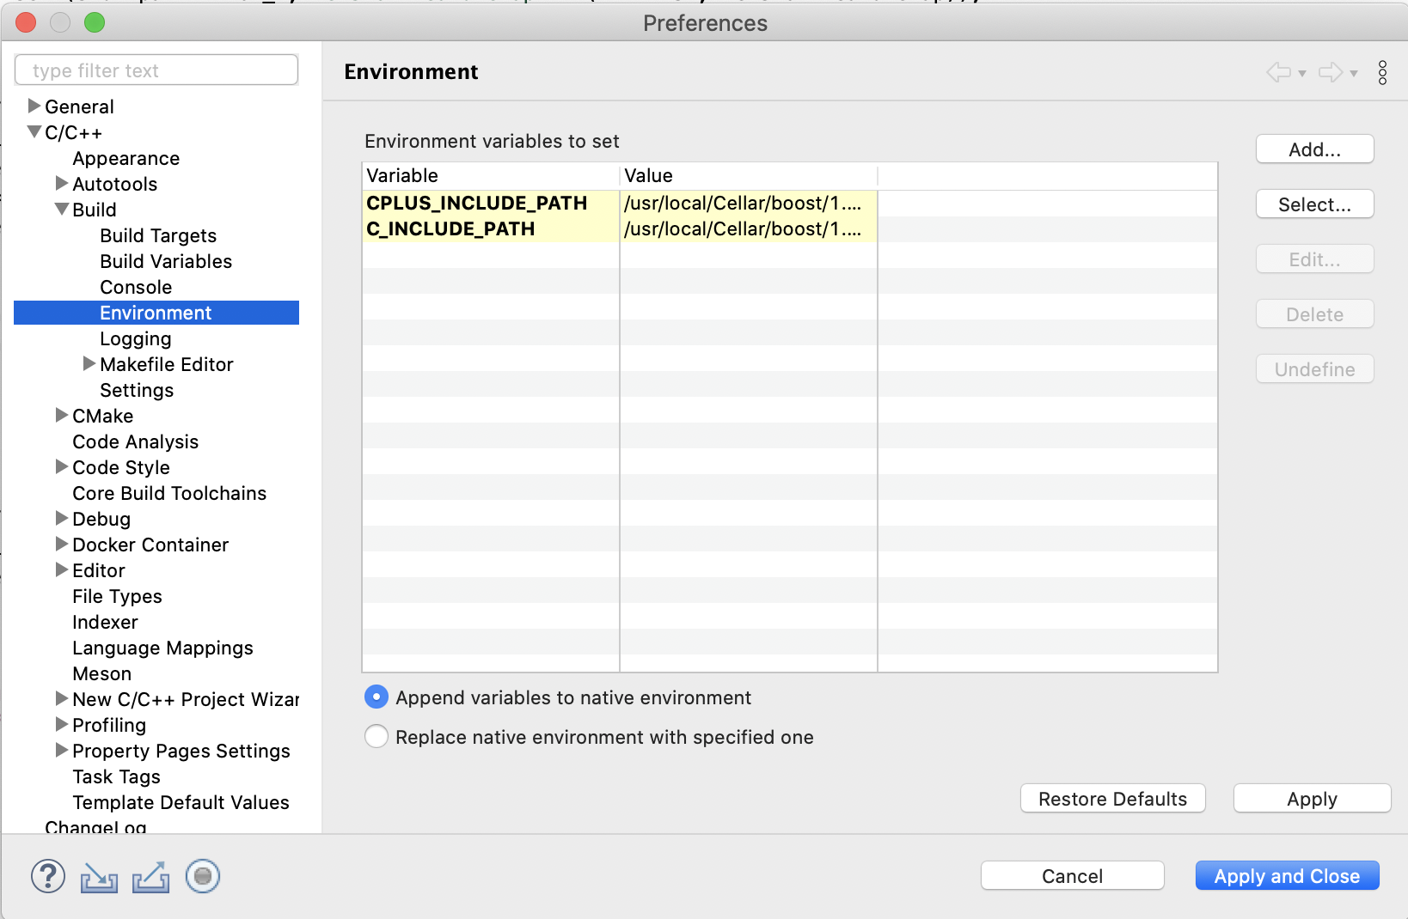

变量之间用冒号”:”而不是分号”;”。